2022 Breakfast with Santa Events were a HUGE SUCCESS!

My heart is so full right now!

We just completed both of our 4th Annual Breakfast with Santa events. In the aftermath of Hurricane Ian, the demand was so great that we decided to host the events in two different locations. A huge thank you to Redeeming Influence Community Outreach (RICO), Mount Hermon Ministries and the First Community Congregational Church for hosting our events on your properties.

We provided valuable health services for the families that needed it the most, but more importantly, in this holiday season, we brought joy to the children that lost so much from the Hurricane Ian and we gave them a chance to have a wonderful Christmas.

We couldn't have done any of this without your support! The outpouring of assistance from our community was truly amazing this year!

We brought smiles back to the kid's faces in many different ways. In addition to your donations of over 500 toys, we also had chance prize giveaways of 16 bicycles and bicycle helmets plus yummy breakfasts provided by RICO, Stacy with King Leo Promotions, and Stephanie with Rozes Sweet Treats. Ricardo Rattis and Hill Madhere, our two amazing DJ's kept the music flowing and Irina with Florida Clowns did beautiful face painting. The kids had the opportunity to meet the firefighters with the City of Fort Myers Fire Department and Lehigh Acres Fire Department, explore the fire trucks, meet firefighters and receive fire helmets. Theyalso toured The Golisano Children's Hospital Neonatal Intensive Care Unit Ambulance. Patch Wihnyk with the Lee County Sheriff's Department VOICE Patrol fingerprinted the kids for the parents. Check out our Premier Mobile Health Services Facebook page to see the amazing pictures of our event taken by our volunteer photographer Lauren Scott.

Our many community partners provided items to the families that are in big demand. Health Start provided diapers and baby formula, Safe Kids with the Golisano Children's Hospital provided the bicycle helmets and safety education, the Florida Health Department administered free flu vaccinations, and the Alliance for Period Supplies of SWFL provided sanitary items, Aetna and Sunshine Health educated the families on different affordable health insurance plans available and Aetna also handed out food bags.

These events are meant to bring fun and joy but they also have a much bigger purpose. When I founded Premier Mobile, it was to bring lifesaving medical care directly into the community and to provide early detection and treatment of medical conditions. These events helped to fulfill that goal. Our medical screenings detected multiple children that are already experiencing high blood pressure. The Bonita Springs Lions Club performed vision screenings and Doctor's Hearing performed hearing tests. Both of these organizations uncovered multiple children that needed follow up vision and hearing care. Advanced Research For Health Improvement (ARHI) performed screenings on the adults and found several people that may be good candidates for some of their clinical trials.

To all of our toy and bicycle donors....all I can say is WOW!! My office turned into "Christmas Central" with all of your donations. Huge thanks to our Board Member Diane Spears and her nursing staff with Lee Health for filling up our transport vehicles with toys and bicycles many times over. Many thanks to The Mail Box Store for providing the big boxes for us to use for toy collection.

Another special thank you to our Board Member Karen Krieger, Director of Community Benefit Outreach with Lee Health. She is one of our biggest supporters and has helped us make so many valuable connections to our community partners. The unwavering support of Lee Health is making it possible for us to fulfill our mission in the underserved communities of Lee County.

In addition to all of the donated items and services, we can't provide these valuable programs without monetary support. A heartfelt thank you to Advanced Research for Health Improvement (ARHI), Neuropsychiatric Research Center (NPRC), The City of Fort Myers, Jim Nathan, Jose Rodriguez, My Sissy Sammi Towne and Marilyn Santiago.

I have to say that I have the very best volunteers that anyone can ask for! Thank you so much for bringing your skills and smiling faces to help us hold these events and help us in our day to day operations. We are able to provide affordable medical care with the assistance of our many medical professionals that volunteer their time with us.

To my incredible staff.... we are so blessed to have you with us on this journey. Every one of you dedicates your heart and soul to our mission and to providing the very best possible care to our patients. We couldn't do any of this without you!

You have heard me say it over and over.... we have the best supporters in the world! I wish you a very happy Holiday Season and a very prosperous 2023. I wish you, your friends and your family, peace, love, and good health both now and in the future!

--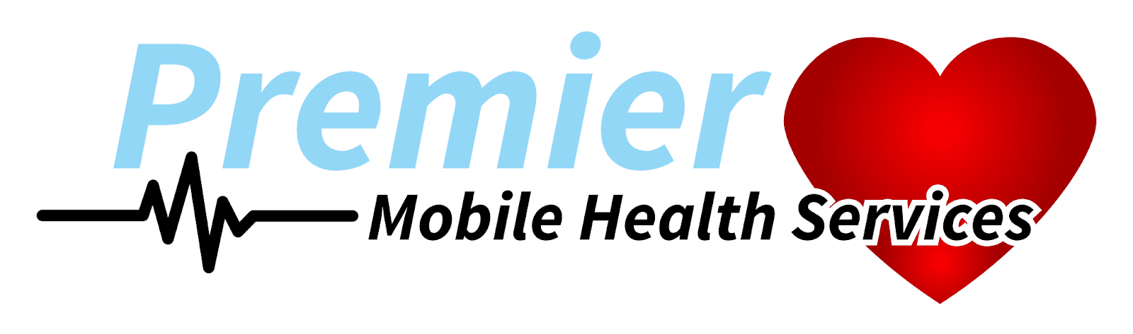
Nadine “Deanie” Singh, APRN, FNP-BC
Executive Director
Your Premier Healthcare Provider

